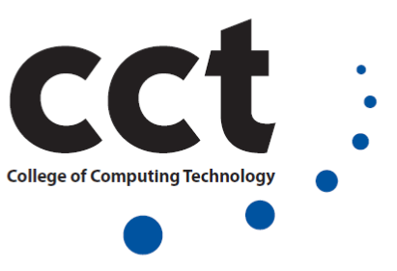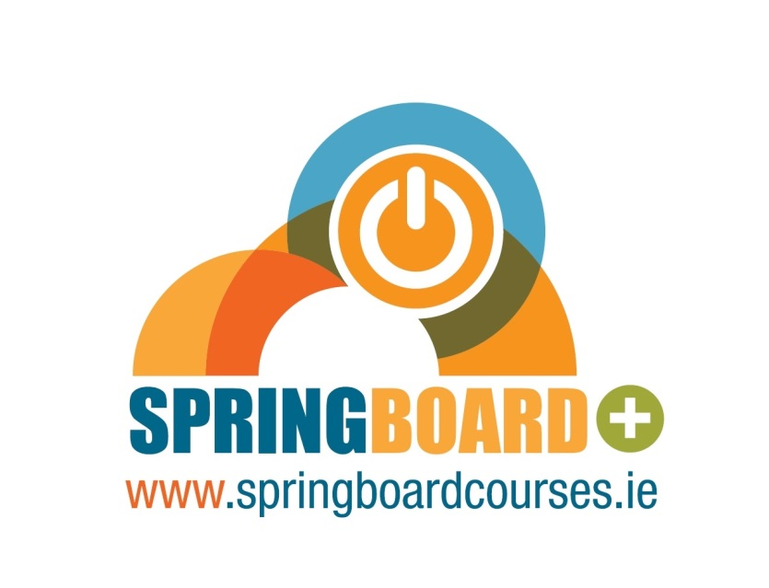
FREE IT COURSE FOR JOBSEEKERS

Level 7 Diploma in Big Data Technology Skills

Dublin City Centre Campus
Register Now!
www.cct.ie/springboard

Springboard 2016 at the College of Computing Technology

The College of Computing Technology is proud to be offering a year-long programme on the 2016 Springboard+ initiative. This programme is delivered at our state-of-the-art City Centre campus.
CCT believes that graduates from this programme will have the potential for employment within the Database areas, and the general ICT sector, and will be well placed to take up employment in many types and sizes of organisations.
Computing programmes at Higher Education level are among the most sought after in Ireland today, considering the continued demand for careers in ICT and more specifically Programming, Software Development, Networking and Databases globally. The Computing and ICT industry has been one of few in the Western world which have effectively survived the recession. It is widely reported within Ireland, that it is still critically short of highly skilled ICT development professionals.

Career Opportunities and Student Supports

The whole nature, structure, and learning delivery of these programmes are practical with job readiness in mind, mainly through the use of practical laboratory sessions throughout the programme. CCT aims to enhance the job readiness of learners by providing the following embedded elements within the programme:

- There is an ICT Work Placement option included within the programme, for the last 8 weeks of the course, and possibly beyond
- There is continuous online and on campus tutorials on CV preparation, job-seeking, job readiness, life-coaching, and interview skills training
- A dedicated Careers Officer is provided by CCT to proactively assist learners with qualified advice and guidance on job-seeking, motivational and stress management techniques, as well as a acting as a student counsellor
- A dedicated Springboard Coordinator is provided by CCT to proactively assist learners with academic and general welfare issues throughout their programme
- Regular workshops (provided monthly for 3 hours) in professional development, academic report writing, stress and time management

Diploma in Big Data Technology Skills
Key Programme Details
Award Diploma NFQ Level 7
Duration 1 year, 12-17 hours/week
Available Part Time ECTS Credits 60 Department Information Technology
General Information
Contact Amanda Russell
Email amanda@cct.ie Phone 01 633 3444
Address CCT, 30-34 Westmoreland St., Dublin 2
Important Dates
Application Deadline 28/09/2016 Start Date 03/10/2016 (week commencing)
About this Course
This programme is an ideal opportunity for candidates to gain employable knowledge, skills, and competencies at Level 7 in Big Data Technology Skills. The programme is designed to provide the learner with a strong foundation in core Data, Big Data, Data Analytics and Data Mining technologies which are very in-demand by industry in today's market. This programme offers a unique opportunity for the learner to shape their learning through a 20 credit Applied Group Technology project in a Big Data topic area of their choosing.

This programme consists of the following 8 modules with added Employability stream for Springboard candidates:

Modules | Semester | Status | ECTS Credits | Stage
Databases | 1 | M | 10 | Award
Business Information Systems | 1 | M | 5 | Award
Cloud Computing Fundamentals & Platforms | 1 | M | 5 | Award
Multi-Paradigm Programming & Scripting | 1 | M | 5 | Award
Applied Technology Group Project | 1 and 2 | M | 20 | Award
Advanced Databases | 2 | M | 5 | Award
Big Data Integration | 2 | M | 5 | Award
Predictive Analytics | 2 | M | 5 | Award
TOTAL Credits |  |  | 60

This programme also opens a path to major awards at levels 7, and 8 and provides learners with the opportunity to pursue careers in areas such as Big Data Analyst, Data Scientist, and Database Manager, including emerging areas which span and integrate these three areas.

This course is a great choice because:
- It provides a basis for further and transfer opportunities in higher education within the IT and Computing fields, particularly Big Data and Analytics
- CCT is a specialist, independent provider of higher education, with a state of the art campus, ideally located in Dublin's city centre
- This programme comprises of practical lab and classroom learning, with supplemental online learning
- It prepares you for an abundance of roles in Big Data and Analytics
- There is an ICT Work Placement option included within the programme
- There is continuous online and on campus tutorials on CV preparation, job-seeking, job readiness, life-coaching, and interview skills training.
CCT believes that graduates from this programme will have the potential for employment within the Data, Big Data and Analytics areas, and the general ICT/Computing sector, and will be well placed to take up employment in many types and sizes of organisations.
Objectives
The overall aim of this programme leading to the Level 7 Special Purpose Award in Big Data Technology Skills is to expose learners to the theoretical concepts that underpin modern Big Data environments, tools and techniques, alongside elements of practical work that will bring them to the standard required of a level 7 programme. To this end, the programme has defined objectives for students:
- Give learners an awareness of the application of Big Data and Analytics in modern business, scientific, financial, social media, internet and computing projects
- Provide learners with the skills required to pursue specified career paths within Big Data Technologies - specifically Big Data Analyst, Data Scientist, Data Specialist, Big Data Support Specialist, Data Manager, Data Management Analyst, and including Data Centre and ISP roles
- Participate in driving the knowledge economy by increasing the knowledge and expertise of programme graduates
- Provide learners with a comprehensive foundation of knowledge, skills, and competencies, within the Data and Big Data specialism
- Equip learners with the knowledge required to continue their studies in IT at levels 7, 8 and above.

Entry Requirements
It would be desirable for any applicant to first have a definite interest and enthusiasm in Big Data and Data Analytics. Applicants should have a basic knowledge of one or more programming languages such as C, C++, C#, Java, Fortran, Python or similar. Applicants without this should contact CCT for more information.
Students younger than 23 on January 1 of the year of course entry must have:
- A minimum of 5 passes in Leaving Cert subjects at higher or ordinary level, including Mathematics and a language (i.e. English, Irish or a European language) OR
- A full FET level 5 award or higher. Applicants must have achieved a pass mark in a Mathematics module in their FET award, or have achieved a pass mark in Mathematics at Leaving Certificate level.
- Mature students (those at the age of 23 or higher on January 1st of the year of course entry) will be required to successfully complete an interview process, with Admissions personnel and the Programme Leader, in accordance with the college’s entry procedures OR
- Mature students do not need to fulfil minimum academic requirements, but may provide a resume with two references, demonstrating their work, academic experience, and/or personal ambition to determine their suitability onto the programme.
- International Applicants, who have not completed the Leaving Certificate or any FET award, will have their secondary school results assessed for their equivalency to the Irish Leaving Certificate in consultation with the QQI guide, CAO and/or NARIC Guide. International applicants should provide an IELTS proficiency score of 6.0 (or TOEFL international equivalent score or CCT English Test and Interview equivalent score)

RPL and RPEL Information
In accordance with Government policy, CCT recognises that Prior Learning for any applicant and learner can take the following forms: 1. formal learning which takes place through programmes of study or training that are delivered by education or training providers, and which attract awards. 2. non-formal learning that takes place alongside the mainstream systems of education and training. It may be assessed but does not normally lead to formal certification. 3. informal learning that takes place through life and work experience. Applicants to CCT can receive recognition for awards, formal learning, and experiential learning received prior to an application for the chosen programme. The College will thoroughly assess potential applications through RPL and RPEL to ensure the applicant is prepared to commence the chosen CCT programme. All applications for RPL and RPEL will be assessed in accordance with CCT RPL and RPEL policy and procedures.
Delivery Location
CCT, 30-34 Westmoreland St., Dublin 2
Application Procedures
Please email info@cct.ie, or amanda@cct.ie, for full information on Application procedures.

